

**College of Engineering – CSE department**

**CMP354 – Mobile application Development**

**Midterm | Fall 22 – 25/Oct/2022**

**Name:**

**ID: Seq. num.:**

|  |  |
| --- | --- |
| **Question # (points)** | **Your score** |
| The main activity XML, 10p  The main activity code, 10p  Search function, 4p  Date functionality, 3p  RSSFeed appending feeds from different sources, 7p  FIO: Downloading and parsing, 6p |  |
| **Total (40)** |  |

1. This is an open-book, open-slides and open-net midterm. You can use your labs/HW as well. Any other aid in any other format is considered cheating.
2. Start by reading the midterm. Questions are allowed during the first 20 minutes only.
3. Students are not allowed to leave and come back during the midterm.
4. Strict university regulations are followed in the event of cheating. An XF will be assigned as a course grade.
5. Switch off your mobile phone (or any other communication device) and do not use it during the exam for any purpose.

Prepare a midterm submission with cover page, code (without backbackground), XML layout, screenshots of results and your apk. Upload it to ilearn safe-assign.

In this midterm you are asked to develop an advanced newsreader app that allows the user to select many news feeds to download, parse and display at once. The app has a functionality that restricts the parsing of the RSS document such that only news items published within specific dates are displayed.

The app also allows the use to restrict the display of news items according to a search term.

The main activity will ask the user to select the feed sources s/he is interested in. One or more feed are allowed from the following list:

String **rssURLs**[] = {  
 **"http://feeds.bbci.co.uk/news/rss.xml"**,  
 **"http://feeds.bbci.co.uk/news/world/rss.xml"**,  
 **"http://feeds.bbci.co.uk/news/business/rss.xml"**,  
 **"http://feeds.bbci.co.uk/news/technology/rss.xml"**};

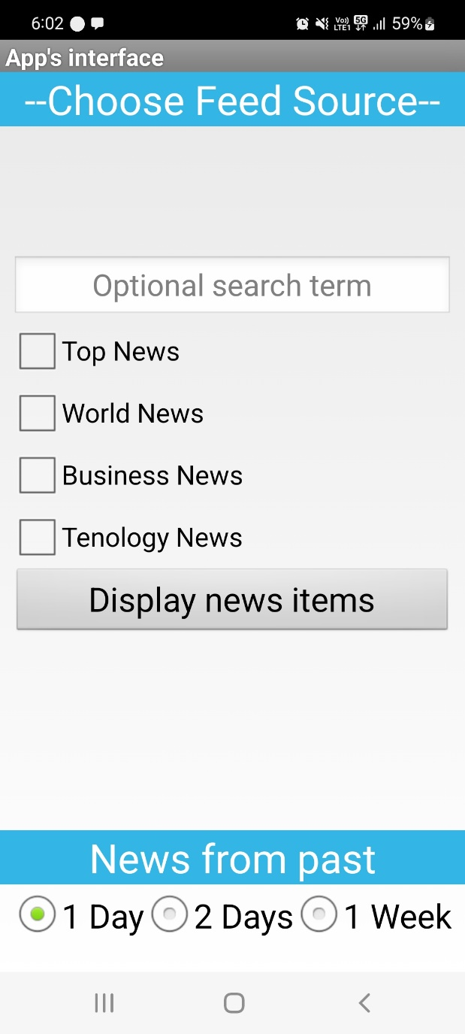

Figure 1. XML design of main activity

If the user selects one or more feed sources then clicks on the “Display news items” button, the download, parsing and display will start.

If the user does not select a feed source then a Toast will show indicating that at least one source should be selected.

An additional requirement:

When the items are displayed, make sure that the “[rss\_topic]” is concatenated to the title such that the user can distinguish between different feeds in the ViewList. The topics in this app are:

String[] rss\_topics = {**"Top News"**, **"Word"**, **"Business"**, **"Technology"**};

In RSSFeed.java

Hint: Create a new function called “append” to create one big list of type “RSSItems”. Recall that:

1. Only items with the specified date range should be added to this list.
2. And if there is a search term, then only items titles that contain the search term are added to the list.

The “append” function can be called from the readFile() function while parsing.

Example:

|  |  |
| --- | --- |
| C:\Users\tshanableh\AppData\Local\Microsoft\Windows\INetCache\Content.Word\Screenshot_20221024-180404_News Reader.jpg  (a) | (b) |

Figure 2. Display of titles from different feed sources

**Searching example:**

The user enters a string to filter the items listed in the ViewList. If the item is not found then the list will be empty. The search is done in a case-insensitive manner.

|  |  |
| --- | --- |
| C:\Users\tshanableh\AppData\Local\Microsoft\Windows\INetCache\Content.Word\Screenshot_20221024-180319_News Reader.jpg | C:\Users\tshanableh\AppData\Local\Microsoft\Windows\INetCache\Content.Word\Screenshot_20221024-180332_News Reader.jpg |

Figure 3. Search Functionality Example